|  |
| --- |
| , RD Dep. |
| **Oracle SQL for Aggregation in Data Warehouses** |

|  |  |  |  |  |  |
| --- | --- | --- | --- | --- | --- |
| REVISION HISTORY | | | | | |
| Ver. | Description of Change | Author | Date | Approved | |
| Name | Effective Date |
| 1.0 | Initial Version | Volha Kutsevol | 13-Feb-2012 |  |  |
|  |  |  |  |  |  |

Contents

Task 1 3

Task 2 3

Tasks Results 3

# Task 1

Build queries using Oracle SQL for Aggregation:

* ROLLUP
* CUBE
* GROUPING
* GROUPING_ID
* GROUP_ID
* GROUPING SETS

# Task 2

Analyze max, min and summary sales in the report below by:

* December 2000;
* Two channels: Internet and Direct Sales;
* All States.

Build the query using Oracle SQL for Aggregation and design the same report (export results to Excel).

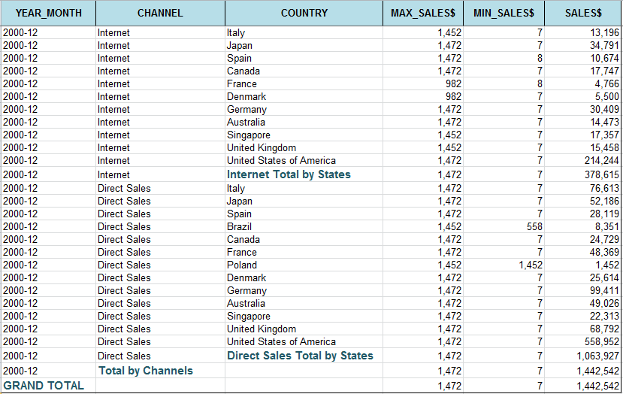

# Tasks Results

Please do tasks above. You must prepare the report with all SQL-scripts and results screenshots. Pack all files into zip-archive (name this archive with your EPAM login: Task_N_name_surname.zip). Send it to [Volha_Kutsevol@epam.com](mailto:Volha_Kutsevol@epam.com)